Active components
Parameter | Method | Range
Dye strength  Compared to standard | John Hogg proprietary | 95 – 105 %
Wavelength of absorbance maxima | Spectrophotometer | 647 – 653 nm
 |  | 554 – 560 nm
 |  | 462 – 472 nm

Physical parameters
Parameter | Method | Range
Density at 15 °C | ASTM D7042 modified | 0.96 – 1.01 kg/L
Viscosity at 20 °C | ASTM D7042 modified | < 50 cP
Flash point | IP 34/ ASTM D93 | > 61 °C
Water content | Karl Fisher | ≤ 0.2 %m/m
Insoluble content | Derived from IP 216 / ASTM D2276 | ≤ 0.2 %m/m
Temperature of crystallisation | - | < -25 °C

Typical use and application
This product can be used for the marking of petroleum products, mineral oils, aliphatic and aromatic hydrocarbon solvents and fuels. The product can be readily pumped, poured or metered directly from the container.

Due to the presence of aromatic solvent in this product, contact with natural rubber must be avoided. For seals and joints the use of PTFE, Viton or similar synthetic products are recommended.

Typical addition rate
This product is designed to be used at a dosage of 1 kg to 50,000 L, or 20 mg/L. Actual dosage will depend upon customer requirements.

Health & safety
Dyeguard® Black GNF has been specifically formulated to provide excellent solubility in functional fluids and be safer to handle without compromising on performance. These minimal handling hazards make Dyeguard® Black GNF ideal for applications with high loading and user exposure.

Further Health and Safety data on this product is available and includes information on handling, storage etc.

Appearance
Dyeguard® Black GNF is a free-flowing dark black/blue liquid with a distinct aromatic odour. It is not miscible with water

Typical viscosity curve
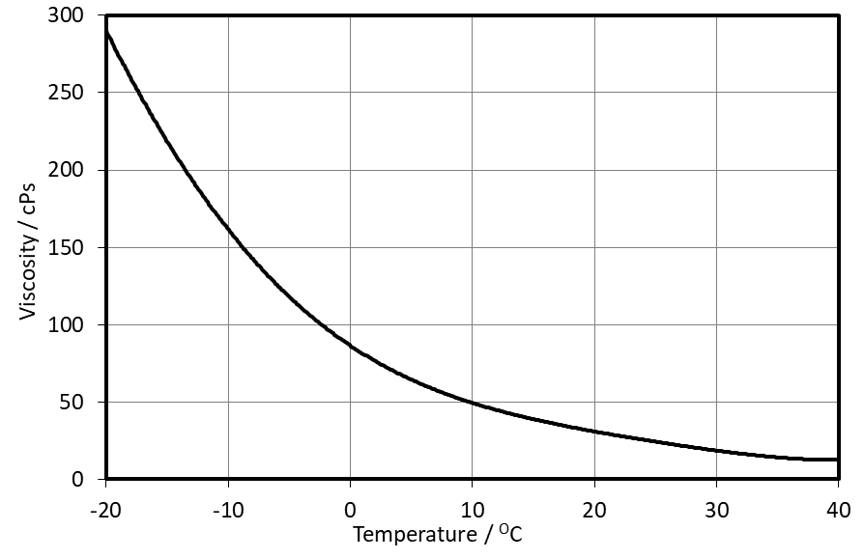

Shelf life and storage condition
This product is stable for a minimum period of 1 year from the date of manufacture, when stored and handled between 5 °C and 40 °C.

The product should always be stored away from excessive heat sources, direct sunlight and ignition sources. Storage and handling of this product outside the above stated conditions may compromise the product quality.

If product containers are kept sealed, dry, and extreme temperatures are avoided the shelf life of the material is greater than 1 year. The container should be tightly closed when not in use to prevent solvent evaporation.

DISCLAIMER
THE INFORMATION CONTAINED HEREIN IS TO THE BEST OUR KNOWLEDGE AND BELIEF, ACCURATE. HOWEVER, SINCE THE CONDITIONS OF HANDLING AND OF USE ARE BEYOND OUR CONTROL, WE MAKE NO GUARANTEE OF RESULTS AND ASSUME NO LIABILITY FOR DAMAGES INCURRED BY FOLLOWING THESE SUGGESTIONS. NOTHING CONTAINED HEREIN IS TO BE CONSTRUED AS A RECOMMENDATION FOR USE IN VIOLATION OF ANY PATENTS OR OF APPLICABLE LAWS OR REGULATIONS. © 2019 JOHN HOGG TECHNICAL SOLUTIONS LTD, ALL RIGHTS RESERVED.

